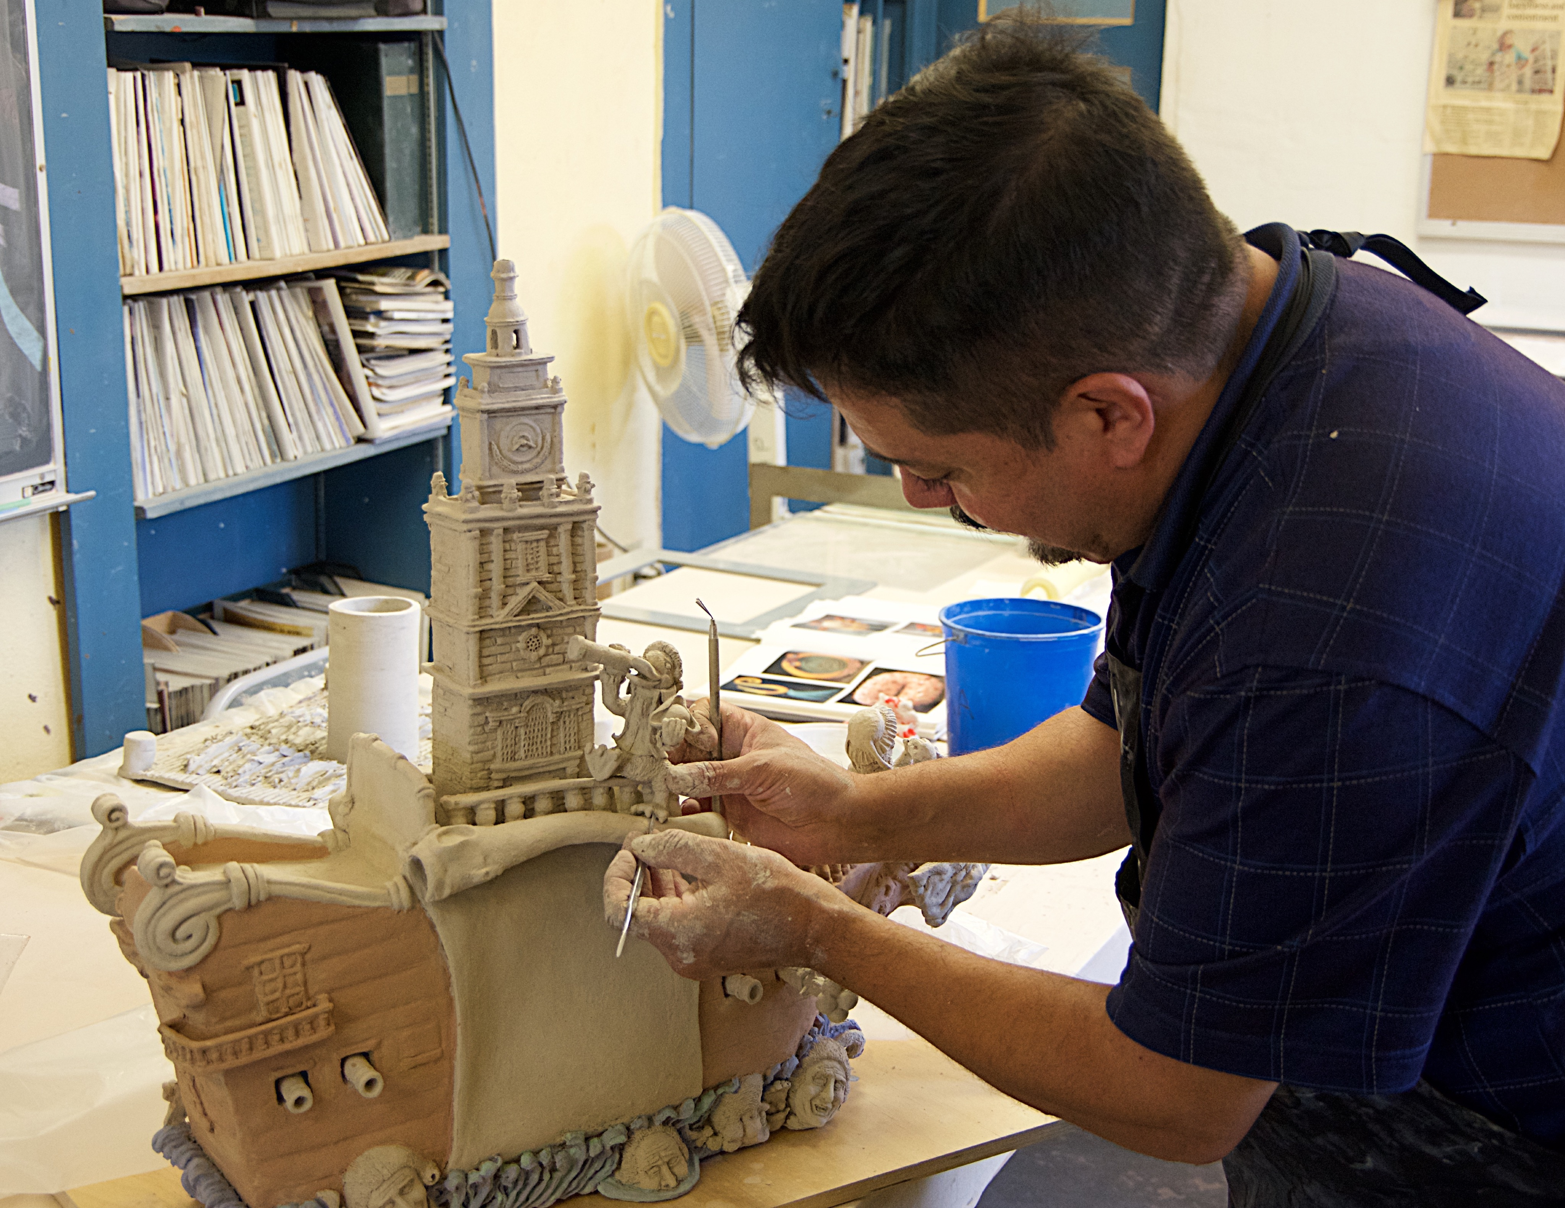
George C. Peñaloza

SCULPTURE • DESIGN • ILLUSTRATION

I have found a way to give voice to my deeper creativity and to bring forth everything within me through the three-dimensional world of ceramic sculpture. My inspirations for working with the free-form and intricate art form of sculpture include fantasy movies and special effects design. Ceramic sculpture gives me an opportunity to give “life” to what exists in my heart and imagination.

Accomplishments and Awards

2021 Tohono Chul Dia de los Muertos Exhibition
For the sculpture “Is That All There Is?”

2020 Mesa Contemporary Arts Museum’s 41st Annual Contemporary Crafts Exhibition
For the sculpture Queen Kraken.
Juror Patty Haberman

2019 Mesa Contemporary Arts Museum’s 40th Annual Contemporary Crafts Exhibition
For the sculpture ​Inspiration Pride.​
Associate Curator Louiza deCamargo

2018 Arizona Biennial Prospectus, Best of State
Tucson Museum of Art
Guest Curator Rachel Adler

2017 Herberger Theatre Center Phoenix, Arizona
Exhibition “Edgy Art”.

2016 Tempe Center for Arts, Tempe, AZ
Tempe Biennial: CLAY
Two entries selected.

2016 Herberger Theater Center, Phoenix, Arizona, “Face Off” Exhibition
For the ceramic sculpture “Andy Taking a Ride”.

2014 NICHE Professional National Finalist, Sculptural Ceramics
Philadelphia Buyers Market of American Craft

2013 Arizona Biennial Prospectus, Best of State
Tucson Museum of Art
Guest Curator Rene Paul Barilleaux

2013 NICHE Professional National Finalist, Sculptural Ceramics
Philadelphia Buyers Market of American Craft

2012 Call to Artists
Pima County Public Library, Joel D. Valdez Branch
Tucson, Arizona

2012 NICHE Professional National Finalist, Sculptural Ceramics
Philadelphia Buyers Market of American Craft

2011 Feats of Clay, Merit Award
Lincoln Arts Foundation
Lincoln, California

2010 NICHE Student National Finalist, Sculptural Ceramics
Philadelphia Buyers Market of American Craft

2010 NCECA Conference International Invitational Exhibition, “Earth Matters”
Moore College of Art and Design
Philadelphia, PA

2009 SandScript
The Literary/Art Magazine of Pima Community College
Category: Sculpture Portfolio and Back Cover

2009 Pima Community College, Best in Three Dimensions Category
Louise Carlos Bernal Gallery Annual Juried Student Exhibition
Tucson, Arizona

2008 Pima Community College, Best in Ceramic Category
Louise Carlos Bernal Gallery Annual Juried Student Exhibition
Tucson, Arizona

2008 NICHE Student National Finalist, Sculptural Ceramics
Philadelphia Buyers Market of American Craft

2007 Arizona Biennial Prospectus, Best of State
Tucson Museum of Art
Guest Curator Diane Perry Vanderlip

2007 Pima Community College, Best of Exhibition
Louise Carlos Bernal Gallery Annual Juried Student Exhibition 2007
Tucson, Arizona

2006 Arizona Student Sculpture Competition, Ceramic Sculpture: Mayor’s Award
Carefree, Arizona

2006 Arizona Designer Craftsmen Awards for Art in Craft Media
Funded by the Susan Chambers Endowment at the Annual Juried Student Art Exhibition
Louis Carlos Bernal Gallery - Pima Community College - Tucson, Arizona

2003 Greater Phoenix Doll & Ceramic Show, Hand-Built Sculpture, Best of Show, Best of Group
Phoenix, Arizona

2002 Arizona Designer Craftsmen, Sculpture: Certificate of Merit

2002 Arizona State Fair, Hand-Built Ceramics: Ann Vaccaro Award, Best of Show, Best of Group
Phoenix, Arizona

2001 Greater Phoenix Doll & Ceramic Show, Hand-Built Ceramics: Exhibitors Association Award
Phoenix, Arizona

1999 Greater Phoenix Doll & Ceramic Show, Hand-Built Ceramics: Best of Show, High First Place and Best of Group
Phoenix, Arizona

1997 Greater Phoenix Doll & Ceramic Show, Hand-Built Ceramics: Prestigious Judges Award, Best of Show, High First Place and Best of Group
Phoenix, Arizona

1994 Arizona Ceramic Artists Association, Hand-Built Ceramics: Best of Class
Phoenix, Arizona

1981 Jobs for Arizona Graduates Poster Competition, First Place: Regional and State

Galleries and Exhibitions

2021Tucson Jewish Community Center
The Art of Sculpture

2021 Tohono Chul
Dia de Los Muertos

2014 BICAS Presents: Tucson Sculpture Festival
Curator Tanya Rich

Details Art & Design
Tucson, Arizona
Vickie and Michael Schwager (520) 577-1994

Raices Taller 222 Art Gallery & Workshop
Tucson, Arizona
Cessi Taller (520) 888-5335

Obsidian Gallery
Tucson, Arizona
www.obsidian-gallery.com
info@obsidian-gallery.com
Monica Prillaman (520) 241-3987

Publications
2017 Desert Leaf Magazine Tucson Arizona

2014 American Art Collector

2014 BICAS Presents: Tucson Sculpture Festival
Catalog

2006 SandScript
The Literary/Art Magazine of Pima Community College

2009 SandScript
The Literary/Art Magazine of Pima Community College

Education

Pima Community College
Associate’s Degree, Fine Arts, September 2010

The Art Center of Tucson
Certificate of Completion, March 1995

Art Instruction School
Minneapolis, MN
Certificate of Completion, August 1980

